Sharron Blezard Innovation Fellowship

The Rev. Sharron Blezard was a beloved writer for SOLI for close to a decade. In 2021, Sharron entered into the church triumphant after her journey through metastatic cancer. You can learn more about her ministry here.
The Sharron Blezard Innovation Fellowship grants up to $40,000.00 for persons in ELCA ministries who share a passion for stewardship of time, talent, and material/financial resources. Additionally, recipients of this fellowship will be able to implement a creative new resource for ministry that encourages people to embrace their role of steward in creation. Examples of this new resource could include podcasts, YouTube channels, innovation within church building infrastructure, or the creation of a beloved community within a ministry context. Special consideration will be given to historically marginalized communities and new ministry startups. This grant may be renewable pending review. For more information about this fellowship opportunity, please contact SOLI Executive Director, Rev. Dr. Martin Otto-Zimmann at mzimmann@uls.edu.
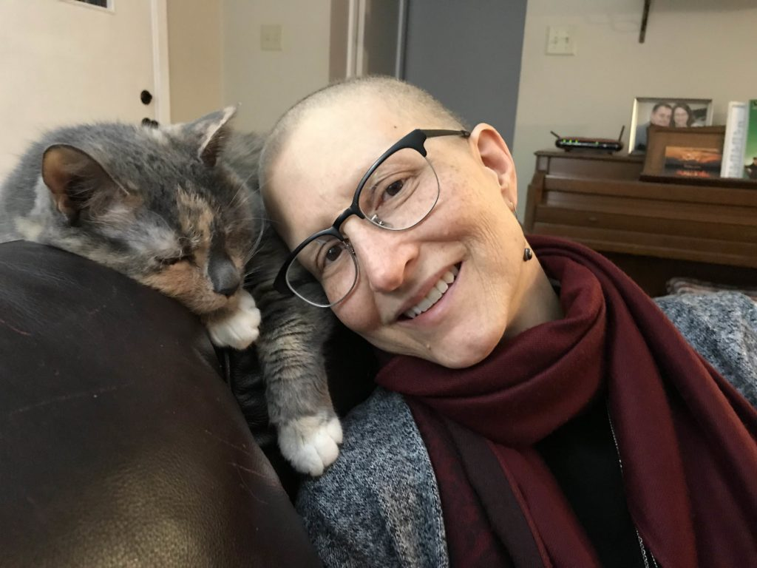
Sharon relaxes at home with her cat, Spatchy, in 2019.

Application for the fellowship can be found here:



